Cloth Warping & Garment Fitting Research Report

1. Introduction
Virtual Try-On (VTO) systems allow users to visualize clothing on their bodies without physically wearing the garments. A critical challenge in these systems is ensuring that clothing naturally fits different body shapes, poses, and sizes.
To achieve realistic fitting, advanced cloth warping and garment alignment techniques are used. These methods transform the clothing image so it aligns accurately with the user's body while preserving garment appearance and texture.
This report studies and compares:
- Thin Plate Spline (TPS)
- Geometric Matching Module (GMM)
- Flow-Based Warping
- DensePose-Based Fitting

2. Cloth Warping Overview

What is Cloth Warping?
Cloth warping is the process of deforming a garment image to match a person's body shape and pose.

Objectives
- Match clothing with body dimensions
- Handle different poses
- Preserve garment texture
- Avoid distortions
- Produce realistic fitting results

Typical Workflow
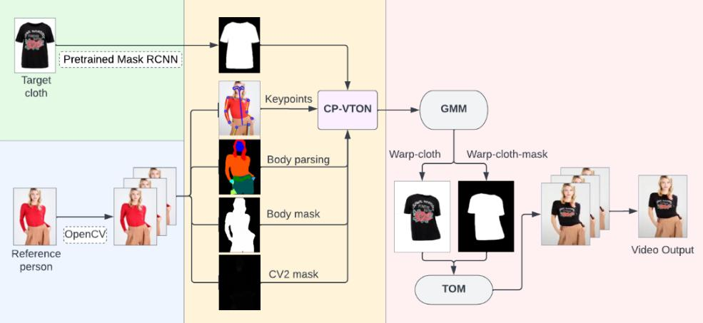

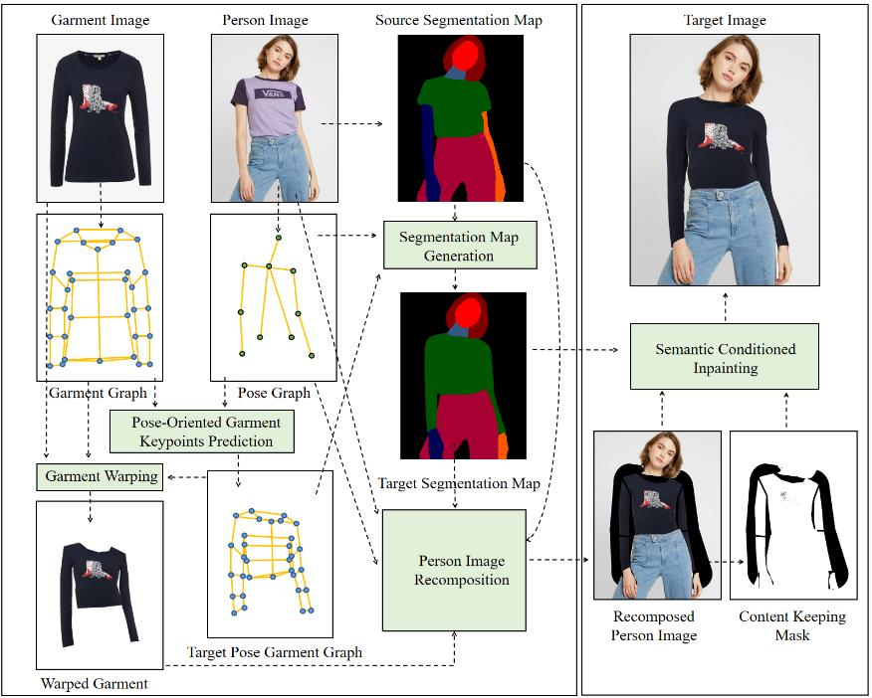
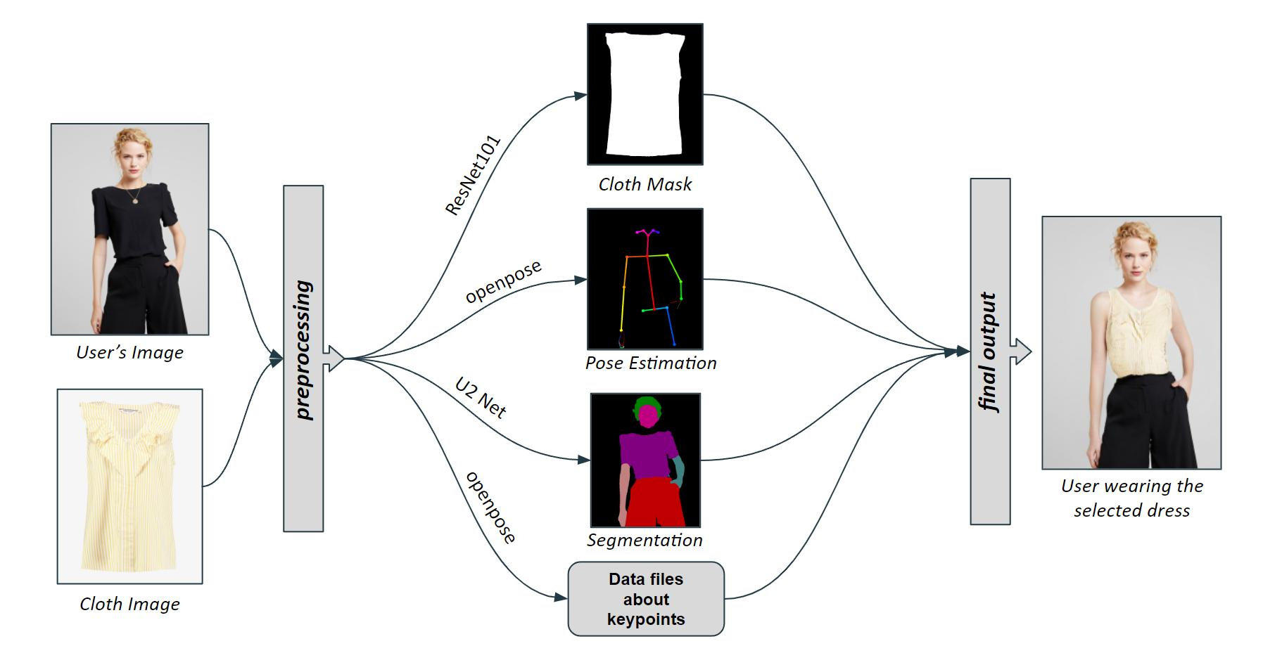

- Person image input
- Body pose detection
- Clothing image extraction
- Garment warping
- Garment fitting
- Final image generation

3. Thin Plate Spline (TPS)

Overview
Thin Plate Spline (TPS) is a mathematical transformation technique widely used in image deformation.
TPS uses a set of control points to smoothly warp one shape into another.

Working Principle
- Detect key body landmarks.
- Identify corresponding garment points.
- Create mapping between garment and body.
- Apply smooth deformation.

Illustration
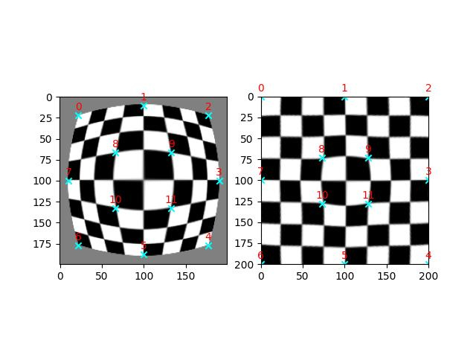
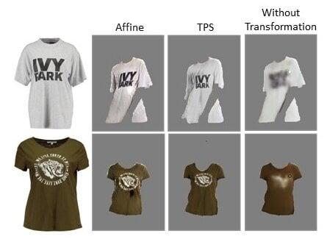
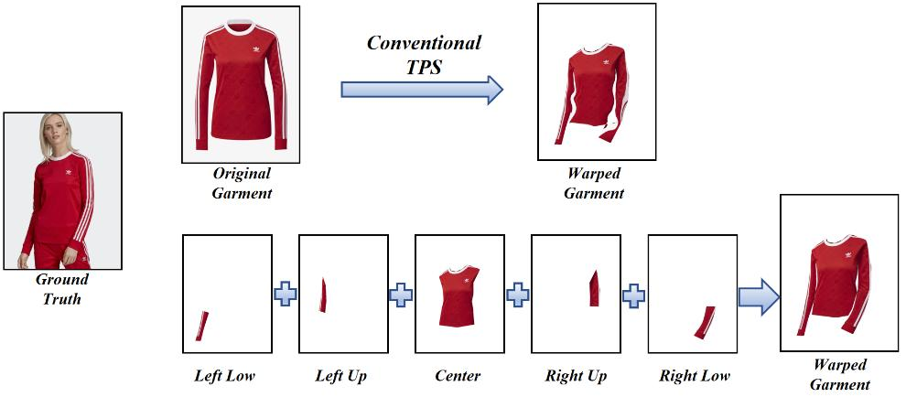
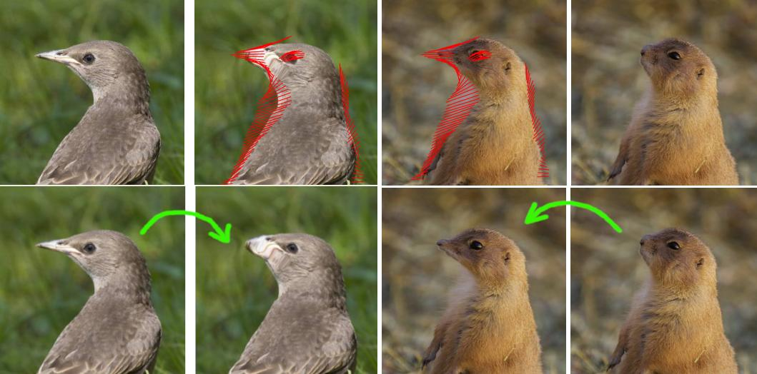

Advantages
✔ Simple implementation
✔ Fast computation
✔ Smooth deformation
✔ Effective for moderate pose changes

Limitations
✘ Cannot handle highly complex body poses
✘ Limited realism
✘ May produce garment distortions
✘ Less accurate for loose clothing

Applications
- Early virtual try-on systems
- Medical image registration
- Face alignment

4. Geometric Matching Module (GMM)

Overview
GMM is a deep learning-based garment alignment technique introduced in the famous virtual try-on framework:
CP-VTON
The module learns how clothing should transform to fit a person's body automatically.

Working Principle
- Extract clothing features.
- Extract body features.
- Calculate correlation between both.
- Predict transformation parameters.
- Warp garment using TPS transformation.

Architecture
Person Features → Matching Network → Transformation Prediction → Warped Garment

Advantages
✔ Higher accuracy than traditional TPS
✔ Learns alignment automatically
✔ Handles pose variations
✔ Preserves garment details

Limitations
✘ Requires training data
✘ Computationally expensive
✘ Depends on dataset quality

Applications
- CP-VTON
- Fashion e-commerce
- AI clothing fitting systems

5. Flow-Based Warping

Overview
Flow-based warping predicts pixel-level movement between garment and body.
Instead of using fixed transformations, every pixel receives a motion vector.

Working Principle
- Extract garment features.
- Analyze body shape.
- Generate optical flow map.
- Move garment pixels according to flow.

Illustration
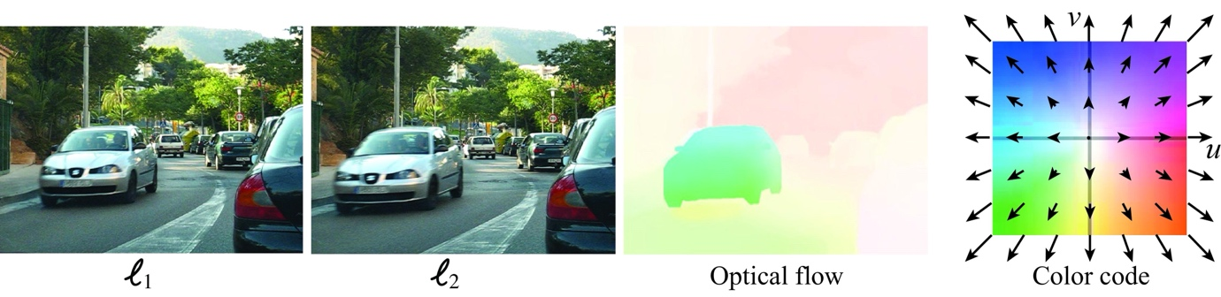
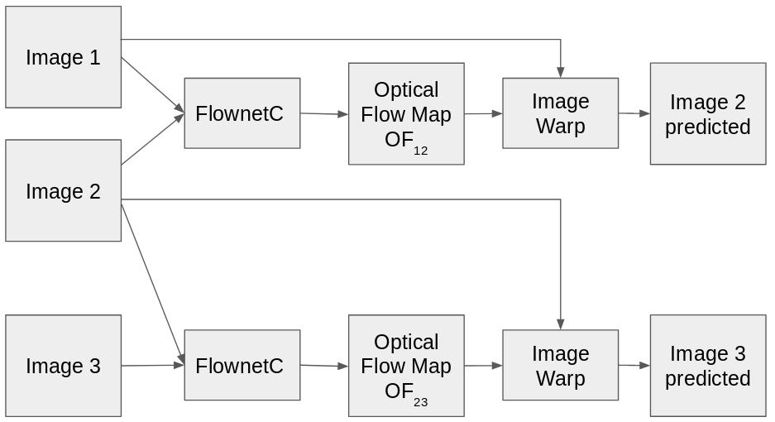

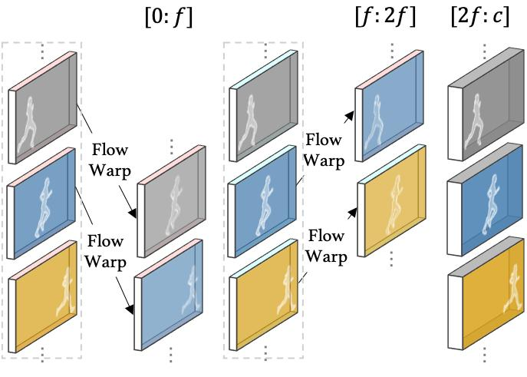
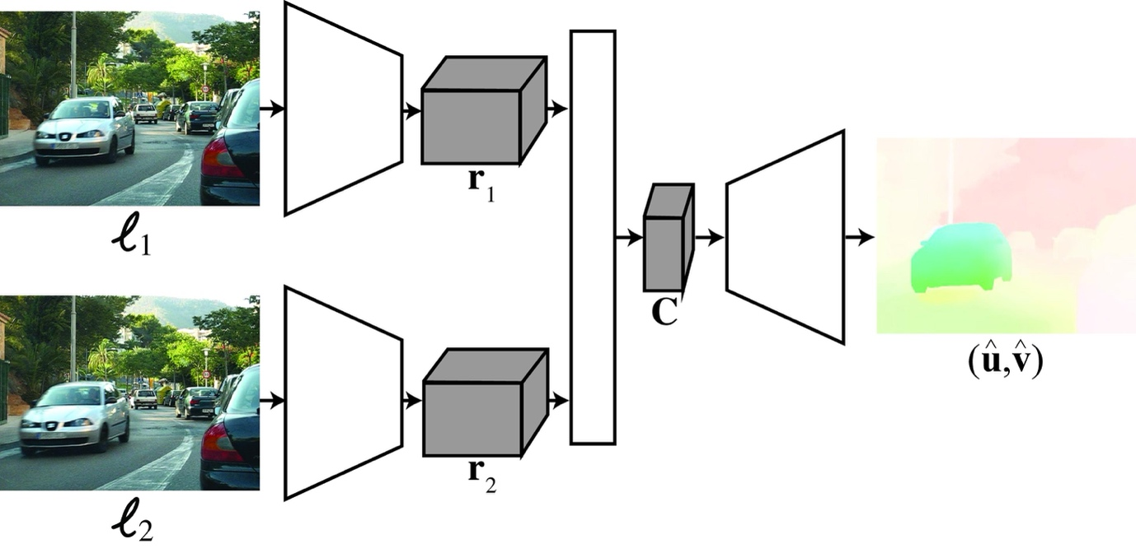


Advantages
✔ Extremely flexible
✔ Handles complex deformations
✔ Better fitting quality
✔ Preserves fine details
✔ Supports difficult poses

Limitations
✘ High computational cost
✘ Longer training time
✘ Requires large datasets

Applications
- Advanced virtual try-on systems
- Motion estimation
- Video synthesis

6. DensePose-Based Fitting

Overview
DensePose maps every image pixel of a human body to a 3D body surface model.
Developed by:
Meta
This allows clothing to be accurately placed on body regions.

Working Principle
- Detect human body.
- Generate DensePose map.
- Match garment regions with body regions.
- Warp garment according to body surface.

Illustration

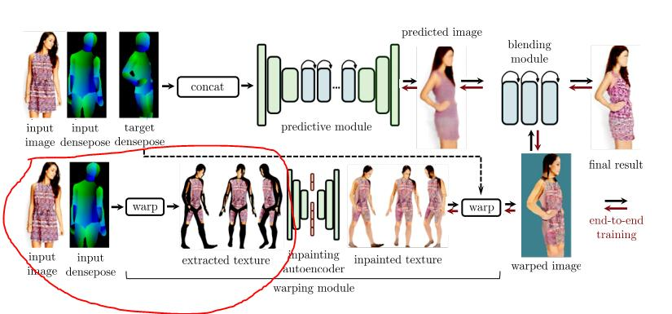
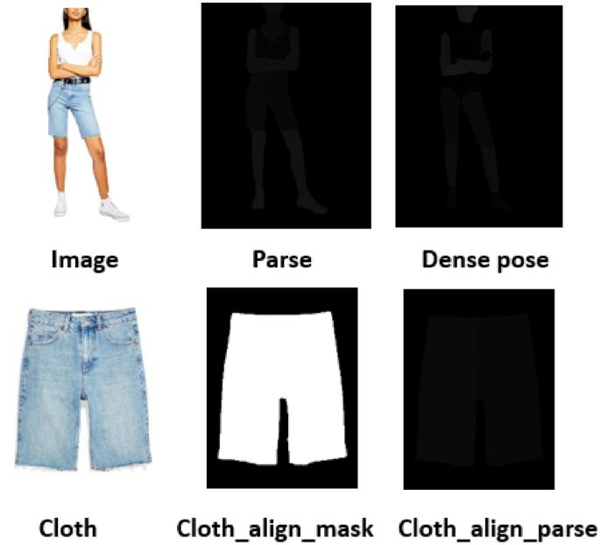
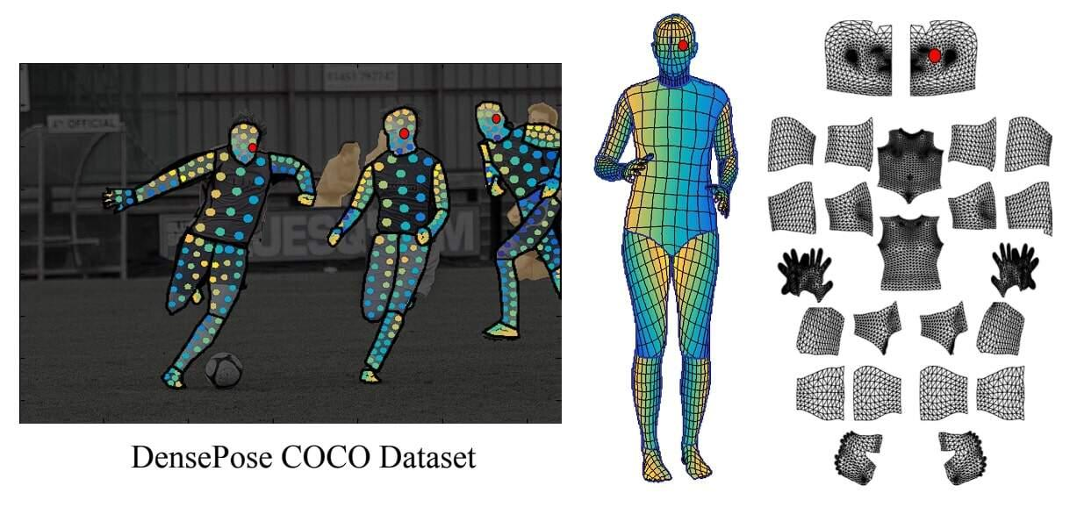

Advantages
✔ Highly accurate body understanding
✔ Excellent pose handling
✔ Supports 3D fitting
✔ Better realism
✔ Accurate body-part mapping

Limitations
✘ Computationally intensive
✘ Complex implementation
✘ Requires powerful hardware

Applications
- 3D virtual try-on
- AR shopping
- Avatar generation
- Metaverse fashion

7. Warping Method Comparison
Feature | TPS | GMM | Flow-Based Warping | DensePose-Based Fitting
Technique Type | Mathematical | Deep Learning | Deep Learning | 3D Body Mapping
Accuracy | Medium | High | Very High | Very High
Training Required | No | Yes | Yes | Yes
Computational Cost | Low | Medium | High | High
Pose Handling | Limited | Good | Excellent | Excellent
Texture Preservation | Medium | High | Very High | High
Realism | Medium | High | Very High | Very High
Implementation Difficulty | Easy | Medium | Hard | Hard
Real-Time Capability | Good | Moderate | Moderate | Moderate
Suitable for Modern VTO | Limited | Good | Excellent | Excellent

8. Garment Alignment Techniques

Landmark-Based Alignment
Uses body keypoints such as:
- Shoulders
- Neck
- Elbows
- Waist
Advantages:
- Fast
- Lightweight
Limitations:
- Less accurate

Segmentation-Based Alignment
Uses human body segmentation masks.
Advantages:
- Better body understanding
- Improved fitting
Limitations:
- Depends on segmentation accuracy

Deep Learning-Based Alignment
Uses neural networks to learn fitting automatically.
Advantages:
- Highly accurate
- Adaptable
Limitations:
- Requires large datasets

9. How Clothing Adapts to Body Shapes
Modern VTO systems adapt clothing through:

Body Shape Estimation
Measures:
- Height
- Width
- Shoulder size
- Waist size

Pose Estimation
Detects:
- Standing pose
- Sitting pose
- Side view
- Hand movements

Garment Resizing
Adjusts:
- Sleeve length
- Shirt width
- Neck position

Fabric Deformation
Simulates:
- Stretching
- Bending
- Folding

10. Research Findings
After studying major cloth warping methods, the following observations were made:

TPS
- Good starting technique
- Fast and lightweight
- Limited realism

GMM
- Significant improvement over TPS
- Popular in virtual try-on research
- Good balance between accuracy and complexity

Flow-Based Warping
- Produces highly realistic results
- Handles complex poses effectively
- Computationally expensive

DensePose-Based Fitting
- Best body understanding
- Suitable for next-generation virtual try-on systems
- Excellent for AR and 3D applications

11. Conclusion
Cloth warping plays a vital role in virtual try-on systems. Among the studied approaches:
- TPS is simple but less accurate.
- GMM provides a strong balance between performance and realism.
- Flow-Based Warping delivers superior garment fitting and detail preservation.
- DensePose-Based Fitting offers the most advanced body-aware fitting and is highly suitable for modern AR/VR virtual try-on applications.
For a modern AI-powered virtual try-on platform, a combination of GMM + Flow-Based Warping + DensePose-based body understanding is recommended because it provides high fitting accuracy, realistic garment deformation, and better user experience.

Final Recommendation
Best Overall: DensePose + Flow-Based Warping
Best Research Framework: GMM
Best Lightweight Solution: TPS
Best Future-Proof Approach: DensePose-Based Fitting with Deep Learning Warping Models.

